MAY MEETING

Tuesday, May 16, 2023

3:00 PM
The May Meeting of the Board of Commissioners of the Collier County Housing Authority will be held at the CCHA’s Main Office, 1800 Farm Worker Way, Immokalee, Florida 34142, on Tuesday, May 16th, 2023, at 3:00 p.m.
AGENDA OF MEETING

- Invocation.
- Pledge of Allegiance.
- Roll Call.
- Approval of the Agenda
- Approval of the Minutes:
  - Meeting Minutes February 28, 2023

- Financial Reports:
  - Review and Approval of Financials through March 31, 2023

- Legal Update:
- Executive Directors Report:
- Old Business:
- New Business:
- Public Comments:
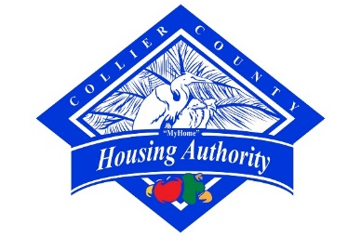
- Announcements:
- Adjournment

