FEBRUARY MEETING

Tuesday, February 28, 2023

3:00 PM
The February Meeting of the Board of Commissioners of the Collier County Housing Authority will be held at the CCHA’s Main Office, 1800 Farm Worker Way, Immokalee, Florida 34142, on Tuesday, February 28, 2023 at 3:00 p.m.
AGENDA OF MEETING

- Invocation.
- Pledge of Allegiance.
- Roll Call.
- Approval of the Agenda
- Approval of the Minutes:
  - Meeting Minutes December 6, 2023

- Audit Presentation by Berman Hopkins Wright & LaHam , CPA and Associates, LLP
- Financial Reports:
  - Review and Approval of November 2022 Financials

- Legal Update:
- Executive Directors Report:

- Old Business:
- New Business:
  - Approval of Holiday Schedule for 2023
  - Authorization to Apply for funding through Collier County
Resolution 23-02-01

- Public Comments
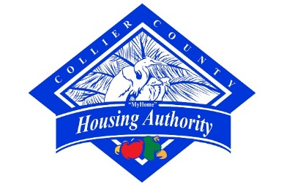
- Announcements
- Adjournment

